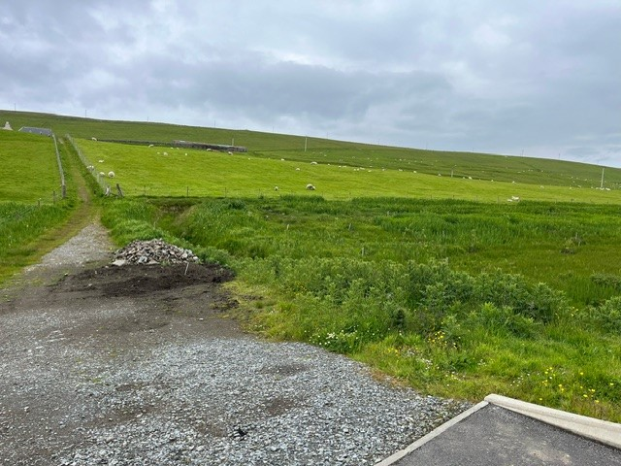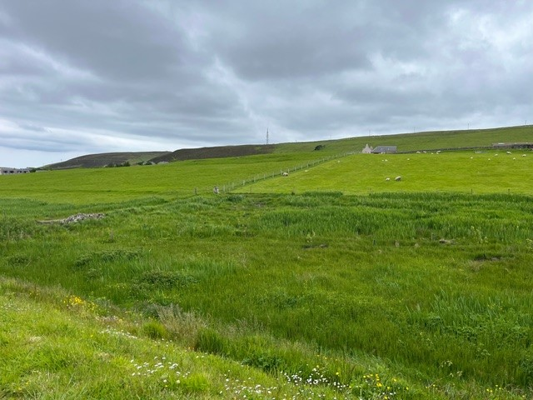

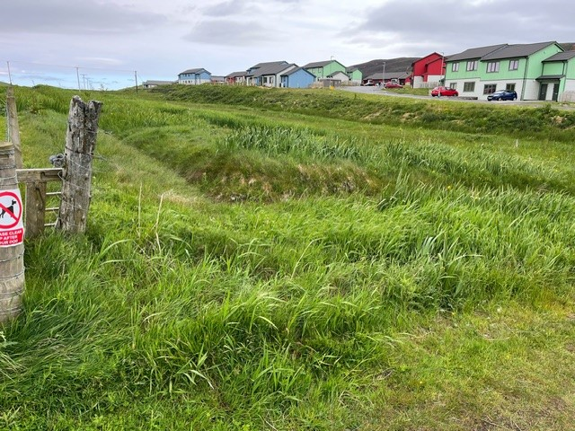

SITE AT UTNABRAKE, SCALLOWAY

The site for sale is approximately 0.0936 of an acre and is situated adjacent to the new dwellinghouses at Berryview, Upper Scalloway. A servitude access will be granted to the Public Road. The site is as shown on SIC Planning Application 2018/251/PPF. The plot is situated in the village of Scalloway and is within walking distance of the Health Centre, Primary School, Swimming Pool and local shops and approximately 6 miles West of Lerwick.

Prospective purchasers should satisfy themselves as regards consents required for any proposed developments and services by contacting Shetland Islands Council Planning Office and the relevant utility providers directly, as no warranties will be given.

VIEWING: By simply visiting the Site

PRICE: Offers over £20,000

SITE AT UTNABRAKE, SCALLOWAY
